
Company
Logotype

Cone Beam Computed Tomography- Report



Porur Dental X-rays & CBCT

Patient Name : Mr. Manokaran | Date of Report : 02.03.2024
Age/ Gender : 37 years/ Male | Region of Interest : CBCT Sectional Mandible
Referring doctor: Dr. Vikram Vishwanath | Indication : Implant assessment- 46
Clinical Notes: Nil
PATIENT INFORMATION

CBCT- Sectional Mandible provided
CBCT – IMAGE DETAILS

RADIOGRAPHIC INTERPRETATION

- Root stumps in relation to 46 with periapical area of hypodensity evident (Root canal treated).
- The alveolar bone in relation to the mandibular ridge is present with normal trabecular pattern.
- Horizontally impacted tooth: 48

IMPLANT ASSESSMENT

 | 46 region
Sub-Crestal (in mm) | 9.13
Mid- Crestal (in mm) | 10.72
Distance between alveolar ridge and the inferior alveolar nerve canal (in mm) | 16.53
Distance between alveolar ridge and the inferior border of mandible (in mm) | 28.25

RADIOGRAPHIC IMPRESSION

- Root Stumps: 46.

Kindly correlate with clinical findings


IMAGES FOR REFERENCE

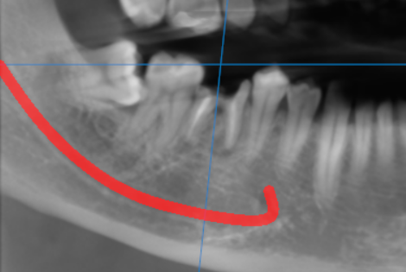

3-DIMENSIONAL VIEW

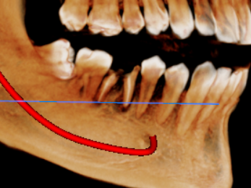

CROSS SECTIONAL VIEW

46 region | 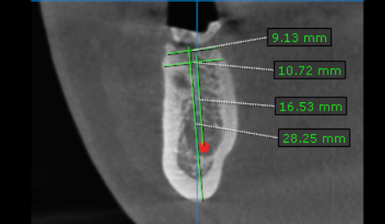

**** End of report ****

